ENV11 Solid & Hazardous Waste: Ch 15 - http://en.wikipedia.org/wiki/Clean_Water_Act

FRESH KILLS LANDFILL
Opened in 1948, it became one of the largest refuse heaps in human history. The site is 12 square km (4.6 square miles) in area. When it was in operation, the contents of twenty barges - each carrying 650 tons of garbage - were added to the site every day. It could be regarded as being the largest man-made structure on Earth, with the site's volume eventually exceeding the Great Wall of China. In fact in 2001 its peak was 25 meters taller than the Statue of Liberty. Under local pressure and with support of the United States Environmental Protection Agency (EPA), the landfill site was closed on March 22, 2001. However, after the September 11, 2001 attacks on the World Trade Center, the landfill was temporarily reopened to receive and process much of the debris from the destruction. The debris was never removed and is buried in a 40 acre portion of the landfill. The New York City Medical Examiner in a written affidavit has stated that he is virtually certain the debris contains human remains.
Waste: Municipal , Industrial, Hazardous, Stream
Plastic Waste, Throw-away Society, Payatas, Phillipines
Open dump: An uncovered site used for disposal of waste without environmental controls.
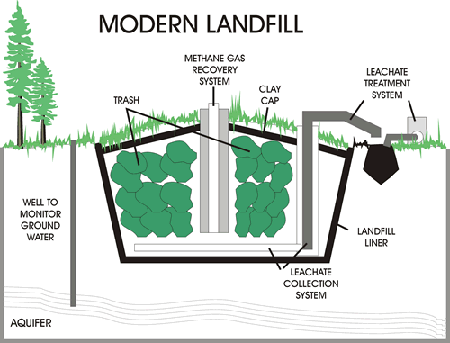
A landfill, also known as a dump is a site for the disposal of waste materials by burial and is the oldest form of waste treatment. Historically, landfills have been the most common methods of organized waste disposal and remain so in many places around the world.
Hazardous waste export causes environmental problems in developing countries. The environmental benefits of reducing waste are negated when waste material is exported.,
Incineration is a waste treatment technology that involves the combustion of organic materials and/or substances. Incineration and other high temperature waste treatment systems are described as "thermal treatment". Incineration of waste materials converts the waste into incinerator bottom ash, flue gases, particulates, and heat, which can in turn be used to generate electric power. The flue gases are cleaned of pollutants before they are dispersed in the atmosphere.
Incinerators reduce the volume of the original waste by 95-96 %, depending upon composition and degree of recovery of materials such as metals from the ash for recycling. This means that while incineration does not completely replace landfills, it reduces the necessary volume for disposal significantly.
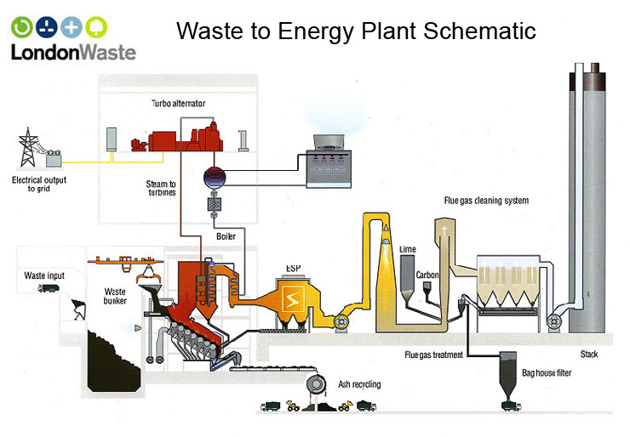
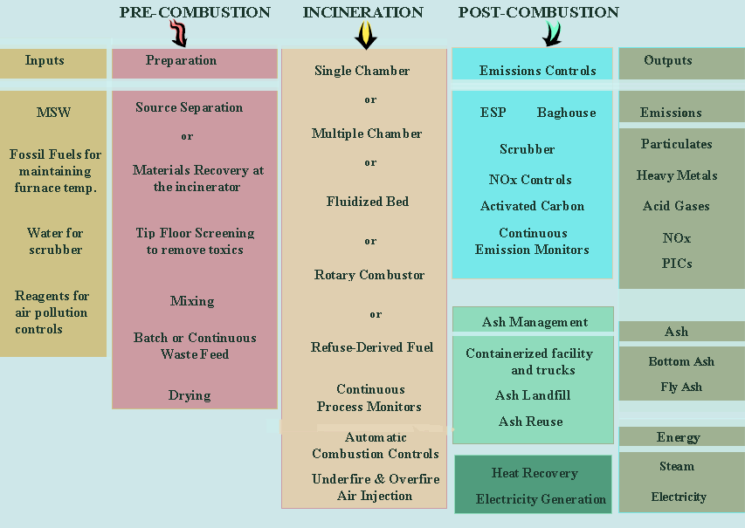
The Resource Conservation and Recovery Act (RCRA), enacted in 1976, is the principal Federal law in the United States governing the disposal of solid waste and hazardous waste. The program exacts stringent bookkeeping and reporting requirements on generators, transporters, and operators of treatment, storage and disposal facilities handling hazardous waste.
The Comprehensive Environmental Response, Compensation, and Liability Act (CERCLA), commonly known as Superfund, was enacted by Congress on December 11, 1980. This law created a tax on the chemical and petroleum industries and provided broad Federal authority to respond directly to releases or threatened releases of hazardous substances that may endanger public health or the environment. Over five years, $1.6 billion was collected and the tax went to a trust fund for cleaning up abandoned or uncontrolled hazardous waste sites. CERCLA:
- established prohibitions and requirements concerning closed and abandoned hazardous waste sites;
- provided for liability of persons responsible for releases of hazardous waste at these sites; and
- established a trust fund to provide for cleanup when no responsible party could be identified.
The law authorizes two kinds of response actions:
- Short-term removals, where actions may be taken to address releases or threatened releases requiring prompt response.
- Long-term remedial response actions, that permanently and significantly reduce the dangers associated with releases or threats of releases of hazardous substances that are serious, but not immediately life threatening. These actions can be conducted only at sites listed on EPA's National Priorities List (NPL).
CERCLA also enabled the revision of the National Contingency Plan (NCP). The NCP provided the guidelines and procedures needed to respond to releases and threatened releases of hazardous substances, pollutants, or contaminants. The NCP also established the NPL..

