Water: Resources and Pollution: Plumbing the Colorado River

Vocabulary: Aquifer, Water table, Flood Plain, Consumptive, Point-source, Eutrophication
- Be familiar with the various processes involved in the water cycle:
Evaporation , Condensation, Precipitation, Runoff, Infiltration, Transpiration (plants loose water through their leaves, that is why they drop them during the Fall season to conserve scarce water)

- Be familiar with the distribution of water in the world between the following:
All Water (Oceans/Saline Lakes and Freshwater) - Freshwater (Ice and Snow and Liquid water)
Liquid Freshwater (Groundwater, soil moisture, lakes/rivers/streams)

- Be familiar with the major sources of fresh water (groundwater, rivers and streams, wetlands and the atmosphere) and some of their characteristics. For example, after ice and snow, groundwater is the second largest source of freshwater. The water table is the region below the earth’s surface where groundwater can be found.

Q1: Where is most of the freshwater (ice snow) found? Q2: What is the largest body of freshwater in the world?

- Be familiar with the major sinks for water (industries, agriculture, municipal and reservoirs).

- Be familiar with the factors affecting groundwater depletion (cone of depression, subsidence, salt water intrusion).

- Be familiar with the sources of groundwater pollution (landfills, septic tanks, leaking gasoline storage tanks etc)

Nutrient (Gulf of Mexico), Pathogen (LA: cryptosporidian), Toxic chemicals (Newtown Creek), Sediment, Thermal.

- Be familiar with the methods of increasing water supplies (cloud seeding, towing icebergs, desalination, etc.) and some of their disadvantages (dams displace a lot of people, destroys wildlife habitat).

- Be familiar with watershed management/conservation techniques and more specifically NYC’s effort to protect the watershed upstate in the Catskills and Croton Reservoir areas. (Land Buy Back).

Las Vegas: Owens Valley, Mono Lake-desertification.

- Be familiar with the sources of water pollution (Farms, industries, etc.)

- Be familiar with the following terms
  - Point Sources / Non-Point sources ii. Pathogens and other infectious agents like E-coli bacteria

- Be familiar with the relationship between oxygen levels in water and the health of the water bodies.
  - Oxygen levels less than 2 ppm are not healthy (smells filthy, encourages the growth of worms, etc.)
  - Oxygen levels greater than 6 ppm support healthy life in water.

- Know the sources and sinks for oxygen in water
  - Oxygen is added to water from air by diffusion
  - Oxygen is added to water by photosynthesis
  - Oxygen is removed from water by respiration and other processes
  - Be familiar with the following terms: Biochemical Oxygen Demand (BOD) which is a measure of the amount of organic material contained in a waste. Oxygen Sag curve.

- Be familiar with the effects of thermal pollution and dissolved oxygen levels and the health of water bodies. (Less dissolved oxygen in hot waters so hot waters do not normally support many aquatic species).

- Be familiar with the various processes in sewage treatment
i. primary treatment- Physical ii. secondary treatment - Aerated to remove organic compounds
iii. tertiary treatment - Chlorine, UV disinfection.

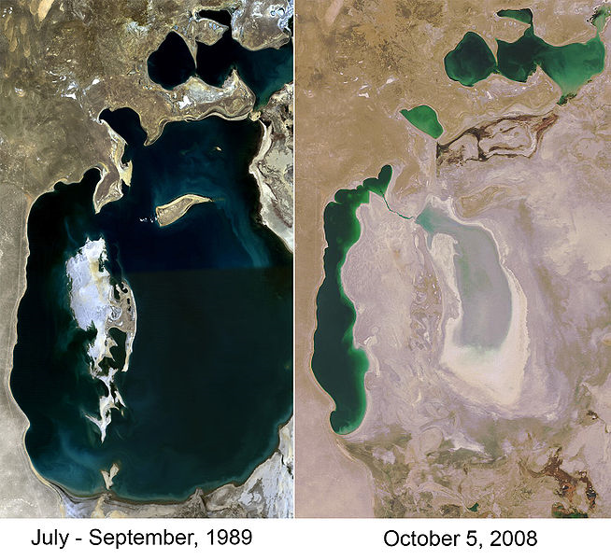
Due to Soviet redirection of the Sea's sources, the Aral Sea has been steadily shrinking since the 1960s. There are now two smaller lakes in the Aral Basin: the North Aral Sea and the western basin of the South Aral Sea. A third lake, the larger eastern basin of the South Aral Sea, dried out completely in 2009.
The maximum depth of the sea is 102 feet (31 m).
After the 2002 Larsen B Ice Shelf disintegration, nearby glaciers in the Antarctic Peninsula accelerated up to eight times their original speed over the next 18 months. Similar losses of ice tongues in Greenland have caused speed-ups of two to three times the flow rate in just one year. The Wilkins Ice Shelf in Antarctica (the size of Vermont) is in the final stages of collapse and scientists are concerned the event shows climate change is happening faster than previously thought. OOPS. It collapsed! In the last year it lost 694 square miles.
View the Ice Shelves: http://nsidc.org/sotc/iceshelves.html
http://en.wikipedia.org/wiki/Aral_Sea#Environmental_problems

