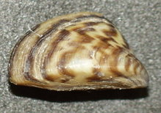
Zebra Mussels: The zebra mussel, Dreissena polymorpha, is a species of small freshwater mussel, an aquatic bivalve mollusk. This species was originally native to the lakes of southeast Russia. However, it has been accidentally introduced in many other areas, and has become a problematic invasive species in many different countries.
Zebra mussels get their name from a striped pattern which is commonly seen on their shells, though not all shells bear this pattern. They are usually about the size of a fingernail, but can grow to a maximum length of nearly two inches (5 cm). The shape of the shell is also somewhat variable. The native distribution of the species is the Black and Caspian Sea. Zebra mussels are an invasive species in North America, the British Isles, Spain, and Sweden.
Zebra mussels are a great nuisance to people. Since colonizing the Great Lakes, they have covered the undersides of docks, boats, and anchors. They have also spread into streams and rivers nationwide. In some areas they completely cover the substrate, sometimes covering other freshwater mussels. They can grow so densely that they block pipelines, clogging water intakes of municipal water supplies and hydroelectric companies.
Also, as their shells are very sharp, they are known for cutting people's feet, resulting in the need to wear water shoes. Zebra mussels are also believed to be the source of deadly avian botulism poisoning that has killed tens of thousands of birds in the Great Lakes since the late 1990s.
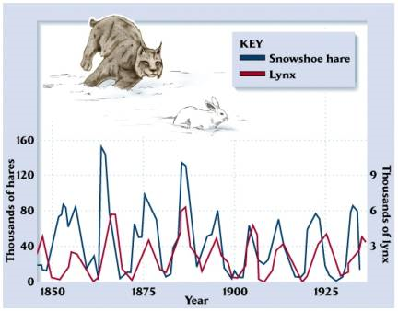
However, zebra mussels and other non-native species are credited with the increased population and size of smallmouth bass in Lake Erie and yellow perch in Lake St. Claire. They cleanse the waters of inland lakes, resulting in increased sunlight penetration and growth of native algae at greater depths. This proves beneficial for fish most of the time, helping the fish live in better conditions. This cleansing also increases water visibility and filters out pollutants.
Species Interactions: Symbiosis, Mutalism, Commensalism, Predation/Parasitism.
Natural Selection: Camouflage, warning coloration, mimicry, coevolution, evolutionary arms race.
Mutalism: Lichen , Plants and fungi, Pollination
Commensalism: Barnacles, Remora and shark.

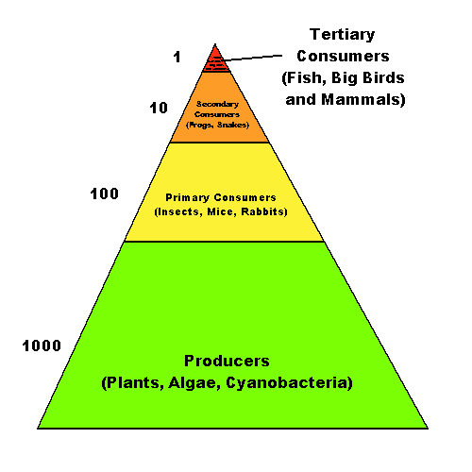
-------------------------------------------------------------------------------------------------------------------------------------------------------
Ecological Communities: Trophic levels. Energy loss at each level.
Producers -> Primary consumers -> Secondary Consumers -> Tertiary Consumers ------ Detrivores and Decomposers
-------------------------------------------------------------------------------------------
One idea is that there is a loss of somewhere around 90% of the energy in one level when you go to the next level up. So one pound of cow requires ten pounds of rich plant food (or more). And one pound of lion requires 10 pounds of cow and 100 pounds of plants.
Two consequences of this:
First, it explains why big secondary and tertiary consumers require such large ranges in order to exist. Cougars and bobcats may need tens or hundreds of square miles in order to find enough food.
Second: this offers powerful arguments for vegetarianism. People who eat on the first trophic level leave much smaller ecological footprints than those who eat much more expensive (energy-wise) meat. The land area required to produce plant food eaten directly is at least 10-fold lower than that required to produce meat.
Can you think of any arguments against everyone being a vegetarian?
Keystone Species: Sea Otters, Mountain Lions. Tiger sharks, Galeocerdo cuvier, commonly known as the "wastebasket of the sea" for their habit of eating anything and everything, may not seem like the most obvious keystone species, however their presence in Shark Bay in Western Australia serves to control populations of dugongs and sea turtles who graze on the sea grass beds there.
Biomes are climatically and geographically defined areas of ecologically similar climatic conditions such as communities of plants, animals, and soil organisms, and are often referred to as ecosystems. Biomes are defined by factors such as plant structures (such as trees, shrubs, and grasses), leaf types (such as broadleaf and needleleaf), plant spacing (forest, woodland, savanna), and climate.
1. Temperate deciduous 2. Temperate grassland 3. Temperate Rainforest 4. Tropical Rainforest
5. Savanna 6. Desert 7. Tundra 8. Boreal Forest (Taiga) 9. Chaparral 10. Tropical Dry Forest
http://www.ucmp.berkeley.edu/exhibits/biomes/index.php
_______________________________________________________________________________________________Chapter 4 – Extra: Evolution, Biodiversity, and Population Ecology >> Natural Selection, Selective Breeding, Biodiversity, Speciation, Phylogenetic trees, Fossils, Extinction – Permian 250 MYA , Population Ecology, Passenger Pigeon, Dodo,
