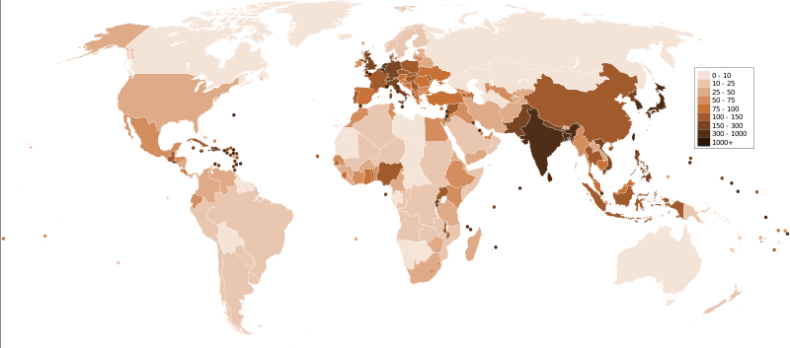
http://www.cosmosmith.com/population_clock.htm
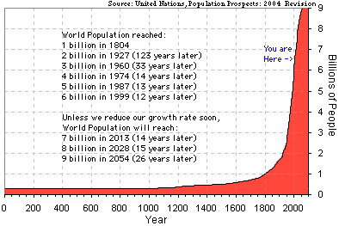
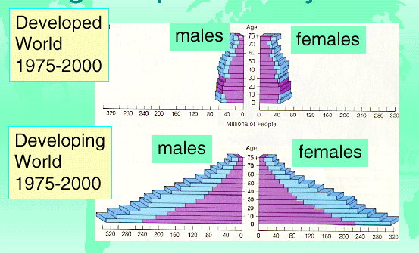
The term world population commonly refers to the total number of living humans on Earth at a given time. As of May 31, 2009, the Earth's population is estimated by the United States Census Bureau to be 6,783,421,727. The world population has been growing continuously since the end of the Black Death around 1400.^{[2]} There were also short term falls at other times due to plague, for example in the mid 17th century. The fastest rates of world population growth (above 1.8%) were seen briefly during the 1950s then for a longer period during the 1960s and 1970s (see graph). According to population projections, world population will continue to grow until around 2050. The 2008 rate of growth has almost halved since its peak of 2.2% per year, which was reached in 1963. World births have leveled off at about 137-million-per-year, since their peak at 163-million in the late 1990s, and are expected to remain constant. However, deaths are only around 56 million per year, and are expected to increase to 90 million by the year 2050. Since births outnumber deaths, the world's population is expected to reach about 9 billion by the year 2040.
People’s Republic of China: One-child policy – Was it a good idea? Should we do it here? If not, why and what other options are there?
105:100 , 120-138:100 – Male : Female Births.
Demographics, Carrying Capacity, IPAT Model: I(mpact) = P(opulation) x A(ffluence) x T(echnology), Total Fertility Rate ,
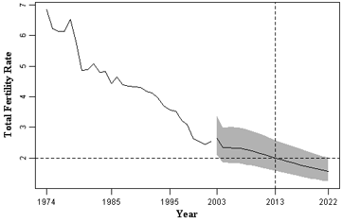
Fertility in Bangladesh: Predictions.
Area - Total 147,570 km² (94th), 55,599 sq mi - Water (%) 7.0
Population - 2007 estimate 161,300,000 (7th) - Density 1045/km² (5th) 2,706/sq mi
Iowa
Area Ranked 26th in the US - Total 56,272 sq mi, (145,743 km²) - % water 0.71
Population Ranked 30th in the US - Total 3,002,555 (2008 est.) - Density 53.5/sq mi/sq mi (53.5/sq mi/km²) Ranked 35th in the US

Does having many children make people poor? Or does being poor make people have many children?
That is a hot question in the continuous struggle over how to spend foreign aid money. Those who think population growth causes poverty advocate programs in family planning and population education. Those who think poverty causes population growth favor direct economic aid, jobs, capital investment. Take care of development, they say, and the birth rate will take care of itself.
Advocates of both sides have come to the village of Manupur in the province of Punjab in north India to prove themselves right.
There is nothing special about Manupur. It is a typical Indian village, with a population in 1950 of about 1200, mostly farmers. Its people are not well off, though their lives are slowly improving. New seeds, fertilizers, and credit systems have caused wheat yields to quadruple since 1950.
In 1953 a team from the Harvard School of Public Health came to Manupur to try out one of the world's first family planning programs. They visited all homes regularly, took a census, and registered all births and deaths. They also instructed people about modern methods of birth control and handed out free contraceptives.
The Harvard team expected that the birth rate would fall. The Punjabis were rural, poor and uneducated. They had an average of seven children per family. Many young people migrated to the city to find jobs; the ones who stayed inherited smaller and smaller plots of land. Surely if families knew how to prevent having so many children, they would have fewer.
The people of Manupur politely accepted the contraceptive foams and jellies. At the beginning of the Harvard study their birth rate was about 40 babies per 1000 people per year. Six years later the birth rate had gone down a little, to 37.7. But the birth rate had also gone down all over the Punjab, even where there were no family planning programs.
The Harvard researchers concluded that the villagers were not so ignorant after all. Family size had always been controlled with crude methods such as abstinence and self-induced abortion. Increasing prosperity caused people to want smaller families, because there was less need for children to work in the fields or support parents in their old age. Once that happened, birth rates went down. Modern contraceptives helped them go down more easily and quickly.
The next visitor to Manupur was Mahmood Mamdani, an Indian who had grown up in Africa and been educated in the United States. He arrived in 1970, by which time Manupur's population had increased to 1800. Its birth rate had continued to decline slowly, to 35 per 1000. Mamdani came to demonstrate that children were the only protection poor people had, and that contraceptives were not needed, not wanted, a totally inadequate substitute for the thorough political and economic revolution he advocated.
Mamdani reported that only the rich in Manupur used birth control. The poorer the person he interviewed, the more that person needed many children simply to stay alive. He quotes a carpenter,
"If I have sons, they will work outside, labor even as animals do, but save. While the rest work, one son will learn the new skills. And maybe we will even be able to get some machinery with the savings of the other sons. A rich man invests in his machines. We must invest in our children."
The villagers informed Mamdani that they had never used Harvard's contraceptives. Mamdani describes a house where he found "small rectangular boxes and bottles, one piled on top of the other, all arranged as a tiny sculpture in a corner of the room." They were contraceptives, used not to prevent births, but to decorate the house.
Twelve years after Mamdani's visit the next set of investigators arrived in Manupur. By 1982 the village's population was 2400, double what it had been in the 1950's. Most of the mud houses had been rebuilt with brick and cement. Nearly half the farmers owned tractors. School enrollment had increased greatly -- 81 percent of the boys and 63 percent of the girls finished the 10th grade. The birth rate was down to 31 per 1000.
The new visitors were Moni Nag and Neeraj Kak, both of Indian descent, now working for the Population Council in New York. The Population Council is a leading funder of family planning programs. And Nag and Kak found that half of all married women in Manupur were using some form of birth control.
Nag and Kak interviewed some of the same people Mamdani had quoted, and found a very different attitude about having children. One of them said, "Children are of no use any more in old age of parents. They also do not do any work while going to school. My son in the military does not keep any connection with me. My son living with me has two sons and one daughter. I have advised him to get a vasectomy."
If different investigators can take their different biases into in the same village and all find what they are looking for, maybe they are all right. Maybe the original question was too simple, assuming "either/or" when the truth is "both/and". Poverty does cause population growth and population growth does cause poverty. Economic development means increasing control of both parts of the cycle; the ability to choose your family size, and the ability to make a living with something more than your hands and the hands of your children.
Question: Should wealthy nations give food and medicines to countries that cannot feed or take care of their peoples? Can you debate for both sides of they argument?

