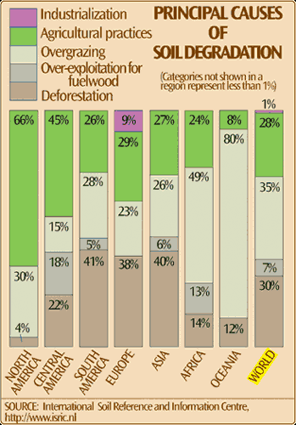
Soil is naturally removed by the action of water or wind: such 'background' (or 'geological') soil erosion has been occurring for some 450 million years, since the first land plants formed the first soil. Even before this, natural processes moved loose rock, or regolith, off the Earth's surface, just as has happened on the planet Mars.
In general, background erosion removes soil at roughly the same rate as soil is formed. But 'accelerated' soil erosion — loss of soil at a much faster rate than it is formed — is a far more recent problem. It is always a result of mankind's unwise actions, such as overgrazing or unsuitable cultivation practices. These leave the land unprotected and vulnerable. Then, during times of erosive rainfall or windstorms, soil may be detached, transported, and (possibly travelling a long distance) deposited.
Accelerated soil erosion by water or wind may affect both agricultural areas and the natural environment, and is one of the most widespread of today's environmental problems. It has impacts which are both on-site (at the place where the soil is detached) and off-site (wherever the eroded soil ends up).
More recently still, the use of powerful agricultural implements has, in some parts of the world, led to damaging amounts of soil moving downslope merely under the action of gravity: this is so-called tillage erosion.
Soil erosion is just one form of soil degradation. Other kinds of soil degradation include salinisation, nutrient loss, and compaction.

Soils are a mixture of different things; rocks, minerals, and dead, decaying plants and animals. Soil can be very different from one location to another, but generally consists of organic and inorganic materials, water and air. The inorganic materials are the rocks that have been broken down into smaller pieces. The size of the pieces varies. It may appear as pebbles, gravel, or as small as particles of sand or clay. The organic material is decaying living matter. This could be plants or animals that have died and decay until they become part of the soil. The amount of water in the soil is closely linked with the climate and other characteristics of the region. The amount of water in the soil is one thing that can affect the amount of air. Very wet soil like you would find in a wetland probably has very little air. The composition of the soil affects the plants and therefore the animals that can live there.

'Slow, insidious' soil erosion threatens human health and welfare as well as the environment, Cornell study asserts
By Susan S. Lang
Around the world, soil is being swept and washed away 10 to 40 times faster than it is being replenished, destroying cropland the size of Indiana every year, reports a new Cornell University study.
Yet the need for food and other agricultural products continues to soar.
"Soil erosion is second only to population growth as the biggest environmental problem the world faces," said David Pimentel, professor of ecology at Cornell. "Yet, the problem, which is growing ever more critical, is being ignored because who gets excited about dirt?"
Plenty of people should be, stressed Pimentel, whose study on the food and environmental threat of soil erosion is published in a recent issue of the Journal of the Environment, Development and Sustainability (Vol. 8, 2006).
"Erosion is a slow and insidious process," stressed Pimentel. "Yet, controlling soil erosion is really quite simple: The soil can be protected with cover crops when the land is not being used to grow crops."
Other ways to reduce erosion include reducing the need for people in developing countries to clear forests for agriculture, overgraze their cattle and remove crop residues for cooking fuel.
The vast majority -- 99.7 percent -- of human food comes from cropland, which is shrinking by more than 10 million hectares (almost 37,000 square miles) a year due to soil erosion, Pimentel reports, while more people than ever -- more than 3.7 billion people -- are malnourished.
"Erosion is one of those problems that nickels and dimes you to death: One rainstorm can wash away 1 mm (.04 inches) of dirt. It doesn't sound like much, but when you consider a hectare (2.5 acres), it would take 13 tons of topsoil -- or 20 years if left to natural processes -- to replace that loss," Pimentel said. "And that kind of loss occurs year after year by wind and rain around the world."
The study, which pulls together statistics on soil erosion from more than 125 sources, reports:
- The United States is losing soil 10 times faster -- and China and India are losing soil 30 to 40 times faster -- than the natural replenishment rate.
- The economic impact of soil erosion in the United States costs the nation about $37.6 billion each year in productivity losses. Damage from soil erosion worldwide is estimated to be $400 billion per year.
- As a result of erosion over the past 40 years, 30 percent of the world's arable land has become unproductive.
- About 60 percent of soil that is washed away ends up in rivers, streams and lakes, making waterways more prone to flooding and to contamination from soil's fertilizers and pesticides.
- Soil erosion also reduces the ability of soil to store water and support plant growth, thereby reducing its ability to support biodiversity.
- Erosion promotes critical losses of water, nutrients, soil organic matter and soil biota, harming forests, rangeland and natural ecosystems.
- Erosion increases the amount of dust carried by wind, which not only acts as an abrasive and air pollutant but also carries about 20 human infectious disease organisms, including anthrax and tuberculosis.
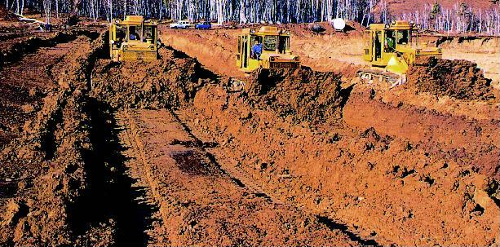
Measuring an average of about 6.6 inches (16.76 centimeters) deep, topsoil is the upper layer of earth’s crust. Topsoil comprises of a mix of humus, mineral and composted materials giving rise to most of the soil’s biological activity and supplying nutrients to plants and therefore to animals. After air and water, topsoil is Earth’s most vital resource.
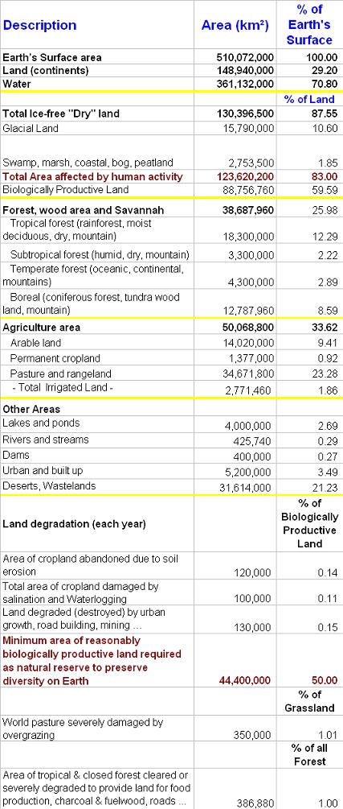
The land you see to the left used to be a forest.

