Non Renewable Energy Sources, Their Impacts, and Energy Conservation
Ken Burns: “The National Parks” on PBS (http://www.pbs.org/nationalparks/watch-video/#872)
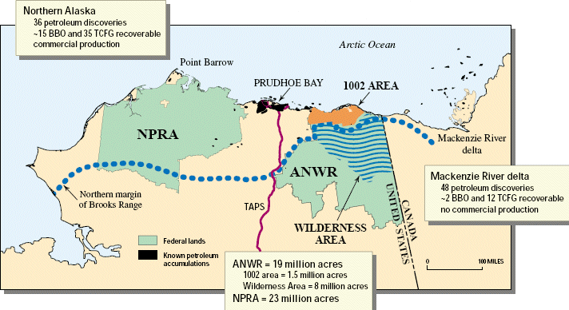
The Alaska North Slope is the region of Alaska located on the northern slope of the Brooks Range along the coast of two marginal seas of the Arctic Ocean, the Chukchi Sea being on the western side of Point Barrow, and the Beaufort Sea on the eastern.
The region contains the National Petroleum Reserve–Alaska, with the bulk of Alaska's known petroleum until the Prudhoe Bay oil field was discovered in 1968, as well as the Arctic National Wildlife Refuge (ANWR), which itself has been the subject of controversy surrounding the possibility of petroleum drilling within its boundaries. The petroleum extracted from the region is transferred south by means of the Trans-Alaska Pipeline System to Valdez on the Pacific Ocean.
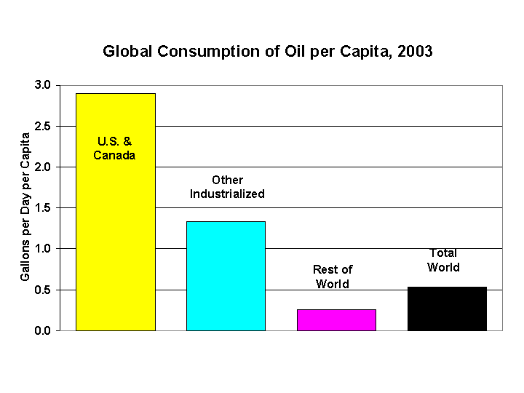
Within the North Slope, only a surface "active layer" of the tundra thaws each season; most of the soil is permanently frozen year-round. On top of this permafrost, water flows to sea via shallow streams or settles into pools and ponds.
Vocabulary: Petroleum, bedrock, tundra, permafrost, decomposers, kerogen, crude oil, natural gas.
1 barrel = 42 gallons. 14 billion barrels = 588 billion gals Fig.15.5, P.344
--------------------------------------------------------------------
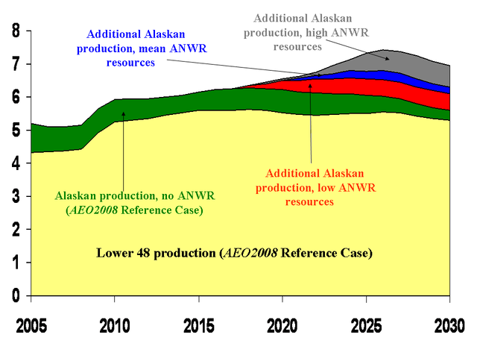
Fossil Fuels: Crude oil, natural gas and coal are fossil fuels. Fossil fuels are very precious resources because they are non-renewable. We also make alot of organic chemicals from them, needed to make products such as paints, detergents, polymers (including plastics), cosmetics and some medicines.
Fossil fuels were formed from the fossilized remains of dead plants and animals that once lived millions of years ago.
Oil and natural gas are the products of the deep burial and decomposition of dead plants and animals. Heat and pressure, in the absence of oxygen, transforms decomposed material into tiny pockets of gas and crude oil.
The oil and gas then migrates through the pores in the rocks to eventually collect in reservoirs.
Coal comes mainly from dead plants which have been buried and compacted beneath sediments. Most coal originated as peat in ancient swamps created many millions of years ago.
Anthracite is a hard, compact variety of mineral coal that has a high luster. It has the highest carbon count and contains the fewest impurities of all coals, despite its lower calorific content.
Bituminous coal or black coal is a relatively soft coal containing a tarlike substance called bitumen. It is of higher quality than lignite coal but of poorer quality than anthracite coal.
Lignite, often referred to as brown coal, or Rosebud coal by Northern Pacific Railroad, is a soft brown fuel with characteristics that put it somewhere between coal and peat. It is considered the lowest rank of coal. Lignite has a high content of volatile matter which makes it easier to convert into gas and liquid petroleum products than higher ranking coals. However, its high moisture content and susceptibility to spontaneous combustion can cause problems in transportation and storage.
Because of its low energy density, brown coal is inefficient to transport and is not traded extensively on the world market compared with higher coal grades. It is often burned in power stations constructed very close to any mines, such as in Australia's Latrobe Valley and Luminant's Monticello plant in Texas. Emissions from brown coal fired plants are generally much higher than for comparable black coal plants. The operation of brown coal plants, particularly in combination with strip mining, can be politically contentious due to environmental concerns.
Lignite is geologically younger than higher-grade coals, originating mainly in the Tertiary period.
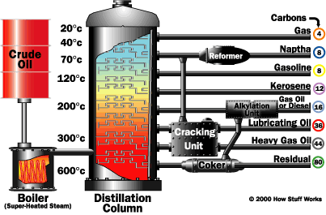
----------------------------------------------------------------------------------------------------------------------------------------------------------
What is crude oil?
Crude oil is a complex mixture of hydrocarbons with small amounts of other chemicals such as sulfur. The crude oil is useless as a mixture and must be sent to an oil refinery to be separated. Crude oils from different parts of the world, or even from different depths in the same oilfield, contain different mixtures of hydrocarbons and other compounds. This is why they vary from light colored volatile liquids to thick, dark oils.
Figure 15.7 (p.337) Hubbert’s Peak 1995, 1-2 trillion barrels
-------------------------------------------------------------

What is natural gas?
 | 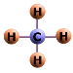 | Natural gas is a mixture of hydrocarbons with small molecules. These molecules are made of atoms of carbon and hydrogen. For example, natural gas used in the home is mainly methane, CH ₄. Natural gas is a combustible mixture of hydrocarbon gases. While natural gas is formed primarily of methane, it can also include ethane, propane, butane and pentane. The composition of natural gas can vary widely, but below is a chart outlining the typical makeup of natural gas before it is refined. Biogenic, Thermogenic.
Typical Composition of Natural Gas
Methane |  |  | CH₄ | 70%-90%
Ethane |  |  | C₂H₆ | 0%-20%
Propane |  |  | C₃H₈
Butane |  |  | C₄H₁₀
Carbon Dioxide |  |  | CO₂ | 0%-8%
Oxygen |  |  | O₂ | 0%-0.20%
Nitrogen |  |  | N₂ | 0%-5%
Hydrogen Sulfide |  |  | H₂S | 0%-5%
Rare gases |  |  | Ar, He, Ne, Xe | Trace
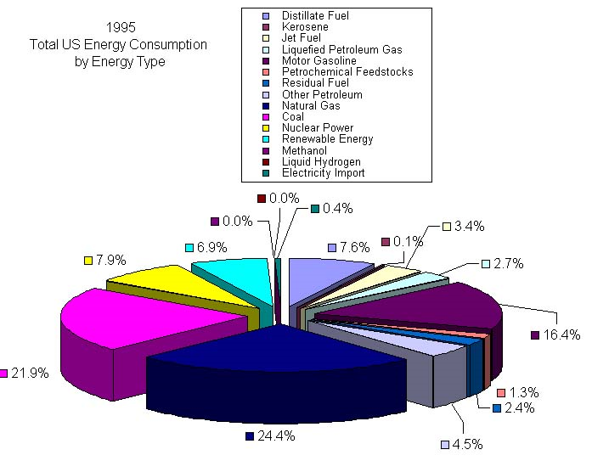
Natural gas, might be considered a very uninteresting gas - it is colorless, shapeless, and odorless in its pure form. Quite uninteresting - except that natural gas is combustible, and when burned it gives off a great deal of energy. Unlike other fossil fuels, however, natural gas is clean burning and emits lower levels of potentially harmful byproducts into the air.

Oil sands, also known as tar sands, or extra heavy oil, is a type of bitumen deposit. The sands are naturally occurring mixtures of sand or clay, water and an extremely dense and viscous form of petroleum called bitumen. They are found in large amounts in many countries - Sometimes called extra heavy crude – Venezuela.
Oil Shale: The name oil shale represents a double misnomer, as geologists would not necessarily classify the rock as a shale , and its kerogen differs from crude oil. Kerogen requires more processing to use than crude oil, which increases its cost as a crude-oil substitute both financially and in terms of its environmental impact. Industry can also burn oil shale directly as a low-grade fuel for power generation and heating purposes and can use it as a raw material in chemical and construction-materials processing.

The Chernobyl disaster was a nuclear reactor accident that occurred on 26 April 1986 at the Chernobyl Nuclear Power Plant in Ukraine (then part of the Soviet Union). It is considered to be the worst nuclear power plant disaster in history and the only level 7 event on the International Nuclear Event Scale. It resulted in a severe release of radioactivity following a massive power excursion that destroyed the reactor. Most deaths from the accident were caused by radiation poisoning.
On 26 April 1986 at 01:23 a.m. reactor number four at the Chernobyl plant, near Pripyat in the Ukrainian Soviet Socialist Republic, exploded. Further explosions and the resulting fire sent a plume of highly radioactive fallout into the atmosphere and over an extensive geographical area. Four hundred times more fallout was released than had been by the atomic bombing of Hiroshima.
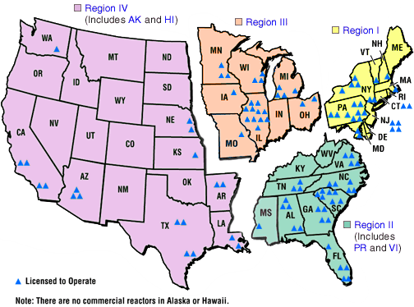
The plume drifted over large parts of the western Soviet Union, Eastern Europe, Western Europe, and Northern Europe, with some nuclear rain falling as far away as Ireland. Large areas in Ukraine, Belarus, and Russia were badly contaminated, resulting in the evacuation and resettlement of over 336,000 people. According to official post-Soviet data, about 60% of the radioactive fallout landed in Belarus.
-------------------------------------------------------
If a massive nucleus like uranium-235 breaks apart (fissions), then there will be a net yield of energy because the sum of the masses of the fragments will be less than the mass of the uranium nucleus. If the mass of the fragments is equal to or greater than that of iron at the peak of the binding energy curve, then the nuclear particles will be more tightly bound than they were in the uranium nucleus, and that decrease in mass comes off in the form of energy according to the Einstein equation. For elements lighter than iron, fusion will yield energy.
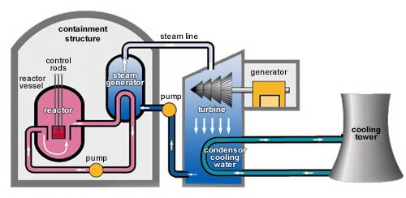
The fission of U-235 in reactors is triggered by the absorption of a low energy neutron, often termed a "slow neutron" or a "thermal neutron". Other fissionable isotopes which can be induced to fission by slow neutrons are plutonium-239, uranium-233, and thorium-232.
>>>>>>>>>>>>>>>>>>>>>>>>>>>>>>>>>>>>>>>>>>>>

Pros and cons of each non-renewable energy source.
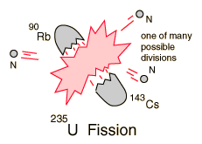
* Dependence on Foreign Reserves = $800,000,000,000, Carbon Cycle, Exxon Valdez, water pollution, acid rain, Nigeria (Ogoni People, Shell, Ken Saro-Wiwa RIP 1994), Nuclear waste…etc.
* Next class: How do we convert to Renewable Energy?
* What are renewable energies?

