Environmental Conservation

- Be familiar with the main vegetation zones of the world’s forests.

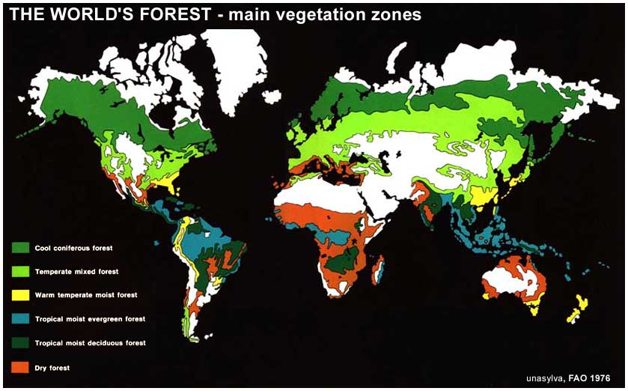

- Be familiar with the changes in the world’s forests in various parts of the world and the reasons for the changes.
A group of forest scientists has warned that unless immediate action is taken, climate change could have a devastating effect on the worlds forests and the nearly 1 billion people who depend on them for their livelihoods.
The researchers, from the Center for International Forestry Research (CIFOR), called for the implementation of adaptation measures to reduce the vulnerability of forests and forest-dependent communities that will experience an unprecedented combination of climate change-associated disturbances like flooding, drought, wildfire, and other environmental challenges in the next 100 years.
- Be familiar with the effects of issues and effects of tropical deforestation.

Stretching out from the equator on all Earth’s land surfaces is a wide belt of forests of amazing diversity and productivity. Tropical forests include dense rainforests, where rainfall is abundant year-round; seasonally moist forests, where rainfall is abundant, but seasonal; and drier, more open woodlands. Tropical forests of all varieties are disappearing rapidly as humans clear the natural landscape to make room for farms and pastures, to harvest timber for construction and fuel, and to build roads and urban areas. Although deforestation meets some human needs, it also has profound, sometimes devastating, consequences, including social conflict, extinction of plants and animals, and climate change—challenges that aren’t just local, but global. NASA supports and conducts research on tropical forests from space-based and ground-based perspectives, helping provide the information that national and international leaders need to develop strategies for sustaining human populations and preserving tropical forest biodiversity.

- Be familiar with the products of forests products and the world consumption pattern of wood in particular.

Forests are being destroyed to make toilet paper, facial tissues, paper towels and other disposable paper products. You can help stop this destruction by pressing manufacturers to use recycled content and clean manufacturing processes, and by making smart shopping decisions.

- Be familiar with issues related to temperate forests.
  - logging of old growth
Old-growth forest is a type of forest that has attained great age and so exhibits unique biological features. Old-growth forest typically contains large and old live trees, large dead trees, and large logs. Individual tree mortality creates gaps in the main canopy layer, allowing light to penetrate the main canopy and create favorable photosynthetic conditions for the understory. That is why the understory in old-growth forest is more developed than in immature stands. Old-growth forests are unique, usually having multiple horizontal layers of vegetation representing a variety of tree species, age classes, and sizes, as well as "pit and mound" soil shape with well-established fungal nets. Because old-growth forest is structurally diverse it provides higher-diversity habitat than forests in other stages. Thus, sometimes higher biological diversity can be sustained in old-growth forest, or at least a biodiversity that is different from other forest stages.
- Many old-growth forest stands are threatened by habitat destruction through excessive logging. The resulting destruction reduces biodiversity, affecting not only the old-growth forest itself, but also indigenous species that rely upon old-growth forest habitat.
- Forest that is regenerated after severe disruptions, such as clear-cutting or fire, is often called second-growth or regeneration until enough time passes that the effects of the disturbance are no longer evident. Depending on the forest, this may take anywhere from a century to several millennia. Hardwood forests of the eastern United States can develop old-growth characteristics in one or two generations of trees, or 150-500 years.
- Old-growth forests are often home to rare species, threatened species, and endangered species of plants and animals, making them ecologically significant. One example of a rare species reliant upon old-growth forest is the Northern Spotted Owl. Levels of biodiversity may be higher or lower in old-growth forests compared to that in second-growth forests, depending on specific circumstances, environmental variables and geographic variables. Logging in old-growth forests is a contentious issue in many parts of the world.
endangered species vs jobs - http://www.spectacle.org/196/rich1.html
http://www.encyclopedia.com/doc/1P2-1025093.html
fisheries – http://fishcons.mi.mun.ca/

- Be familiar with the ideas and concepts of parks and preserves both in the United States and abroad.

Parks: http://www.nps.gov/findapark/index.htm
Preserves: http://en.wikipedia.org/wiki/List_of_nature_centers_in_the_United_States

A nature reserve (natural reserve, nature preserve, natural preserve) is a protected area of importance for wildlife, flora, fauna or features of geological or other special interest, which is reserved and managed for conservation and to provide special opportunities for study or research. Nature reserves may be designated by government institutions in some countries, or by private landowners, such as charities and research institutions, regardless of nationality. Nature reserves fall into different IUCN categories depending on the level of protection afforded by local laws.

Be familiar with the U.S. Park system and the various issues that it faces.
Please check this out: National Park Issues http://www.nps.gov/archive/badl/exp/issues.htm

http://www.nps.gov/history/history/online_books/runte1/epilogue.htm JamesWatt – Please read and comment on

  - mining - http://www.nps.gov/history/local-law/FHPL_MininginNPrks.pdf
  - wildlife issues
Kenya’s Wildlife Decline
  - environmental degradation due to use of motor vehicles in the parks

- Be familiar with aspects of the SLOSS debate about the size and design of Nature Preserves.

- Be familiar with issues concerning the balancing act that takes place in many countries between Conservation and Economic Development.

- Be familiar with the arguments for/against the need for more wilderness areas.

