Subsistence agriculture: is self-sufficient farming in which farmers grow only enough food to feed their family. The typical subsistence farm has a range of crops and animals needed by the family to eat during the year. Planting decisions are made toward what the family will need during the coming year, rather than market prices.

Intensive traditional: is an agricultural production system characterized by the high inputs of capital, labor, or heavy usage of technologies such as pesticides and chemical fertilizers relative to land area.

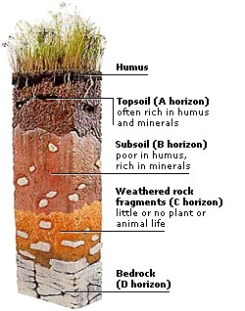
Industrialized agriculture: is a form of modern farming that refers to the industrialized production of livestock, poultry, fish, and crops. The methods of industrial agriculture are technoscientific, economic, and political. They include innovation in agricultural machinery and farming methods, genetic technology, techniques for achieving economies of scale in production, the creation of new markets for consumption, the application of patent protection to genetic information, and global trade. These methods are widespread in developed nations and increasingly prevalent worldwide. Most of the meat, dairy, eggs, fruits, and vegetables available in supermarkets are produced using these methods of industrial agriculture.

A soil profile shows the layers of soil from the surface that may be dark-colored, due to the presence of organic matter, grading down through to minerals of incompletely weathered bedrock.. Some soils are formed from material transported from elsewhere by wind or water.
Characteristics of soil: There is great variability in soils due to the:
- Composition of the bedrock (sedimentary; volcanic; igneous).
- Weathering and erosion-forces (chemical; leaching; grinding; wind; water; glaciers).
- Climate over the period of their formation (aridity; humidity; temperature).
- Time over which the soil-formation forces have been operating (young soils may have been formed since a recent ice age of 20,000 years ago; recent volcanic activity; recent deposition by young rivers)
The A horizon is formed and differentiated by the accumulation of organic matter and its decomposition products through microbial activities. Transitional stages exist between individual horizons and. In practice, it is difficult to clearly demarcate such transitional areas. Nevertheless, the upper most horizon is rich in organic nutrients.
The B horizon is characterized by the accumulation of silicate clay minerals and percolating humans particles while the horizon C consists of weathered parent material. The A, B, and C horizons are interlinked physically, biologically and chemically whereas the lowermost D horizon may consist of hare rock, layers of clay or and which are not part of parent material but may have some relationship to the upper horizons of soil.

Fertilizers are chemical compounds applied to promote plant and fruit growth fertilizers can be placed into the categories of organic fertilizers (composed of decayed plant/animal matter), or inorganic fertilizers (composed of simple chemicals and minerals). Organic fertilizers are 'naturally' occurring compounds, such as peat, manufactured through natural processes (such as composting), or naturally occurring mineral deposits; inorganic fertilizers are manufactured through chemical processes (such as the Haber process), also using naturally occurring deposits, while chemically altering them.
Properly applied, organic fertilizers can improve the health and productivity of soil and plants, as they provide different essential nutrients to encourage plant growth. Organic nutrients increase the abundance of soil organisms by providing organic matter and micronutrients for organisms such as fungal mycorrhiza, which aid plants in absorbing nutrients. Chemical fertilizers may have long-term adverse impact on the organisms living in soil and a detrimental long term effect on soil productivity of the soil.
* Crop rotation, Contour farming, Intercropping, Terracing, Shelterbelts, Conservation tillage (no-till)
* Irrigation, Fertilizers , waterlogging and salinization, overgrazing and its related effects
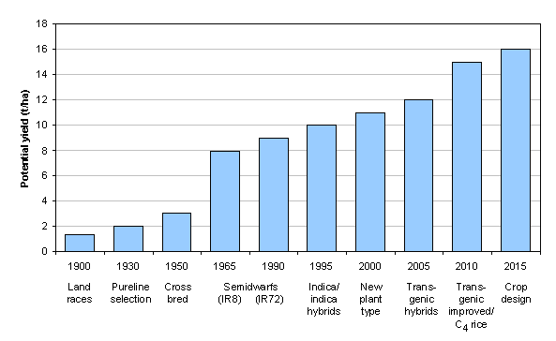
* Biocontrol, Pesticides, Transgenic crops, Genetically modified (GM) organisms

Aquaculture: Transgenic salmon vs wild salmon
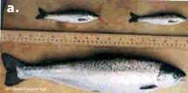
Sustainable agriculture, Organic agriculture
Organic farming is the form of agriculture that relies on crop rotation, green manure, compost, biological pest control, and mechanical cultivation etc... to maintain soil productivity and control pests, excluding or strictly limiting the use of synthetic fertilizers and synthetic pesticides, plant growth regulators, livestock feed additives, and genetically modified organisms. Since 1990, the market for organic products has grown at a rapid pace, to reach $46 billion in 2007. This demand has driven a similar increase in organically managed farmland. Approximately 32.2 million hectares worldwide are now farmed organically, representing approximately 0.8 percent of total world farmland. In addition, as of 2007 organic wild products are harvested on approximately 30 million hectares .
Organic agricultural methods are internationally regulated and legally enforced by many nations, based in large part on the standards set by the International Federation of Organic Agriculture Movements (IFOAM), an international umbrella organization for organic organizations established in 1972. IFOAM defines the overarching goal of organic farming as follows:
"Organic agriculture is a production system that sustains the health of soils, ecosystems and people. It relies on ecological processes, biodiversity and cycles adapted to local conditions, rather than the use of inputs with adverse effects. Organic agriculture combines tradition, innovation and science to benefit the shared environment and promote fair relationships and a good quality of life for all involved.."

