CERCLA Overview
The Comprehensive Environmental Response, Compensation, and Liability Act (CERCLA), commonly known as Superfund, was enacted by Congress on December 11, 1980. This law created a tax on the chemical and petroleum industries and provided broad Federal authority to respond directly to releases or threatened releases of hazardous substances that may endanger public health or the environment. Over five years, $1.6 billion was collected and the tax went to a trust fund for cleaning up abandoned or uncontrolled hazardous waste sites. CERCLA:
- established prohibitions and requirements concerning closed and abandoned hazardous waste sites;
- provided for liability of persons responsible for releases of hazardous waste at these sites; and
- established a trust fund to provide for cleanup when no responsible party could be identified.
The law authorizes two kinds of response actions:
- Short-term removals, where actions may be taken to address releases or threatened releases requiring prompt response.
- Long-term remedial response actions, that permanently and significantly reduce the dangers associated with releases or threats of releases of hazardous substances that are serious, but not immediately life threatening. These actions can be conducted only at sites listed on EPA's National Priorities List (NPL).
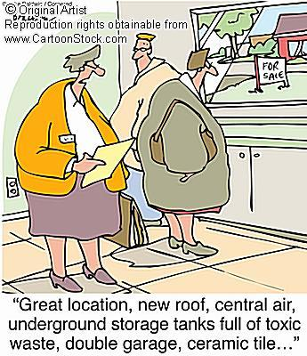
CERCLA also enabled the revision of the National Contingency Plan (NCP). The NCP provided the guidelines and procedures needed to respond to releases and threatened releases of hazardous substances, pollutants, or contaminants. The NCP also established the NPL.
CERCLA was amended by the Superfund Amendments and Reauthorization Act (SARA) on October 17, 1986.
Superfund is the federal government's program to clean up the nation's uncontrolled hazardous waste sites. We're committed to ensuring that remaining National Priorities List hazardous waste sites are cleaned up to protect the environment and the health of all Americans.

Superfund Sites Where You Live - http://www.epa.gov/superfund/sites/index.htm
Find out if there is a Superfund site near your home, what kind of contaminants the site has, and what is being done to clean up the site.
http://www.toxicstargeting.com/toxicmaps/

