Constructive critique:
Each quiz followed the outline exactly. From what I see many of you have not read the book or may not have the text. Some of you, study the parts you understand but leave out the parts you don’t.
No one can make you learn. If you do want to learn then be proactive in asking questions and emailing questions. When I get no response from the student then I can only assume that the student does not want to learn and, for reasons I cannot know, plans just to sit in class wasting her or his time. Think about it.

Preview to Chapter 5: Biomes and Biodiversity
The syllabus removes Chapter 3 which I feel is essential in deep understanding of the environment. It is here (p.49) that the origin of species and their diversity is explained. Here are the basics:
…………………………………………………………………………………………………………………...
Natural selection is one of the basic mechanisms of evolution, along with mutation, migration, and genetic drift.
Darwin's grand idea of evolution by natural selection is relatively simple but often misunderstood. To find out how it works, imagine a population of beetles:
- There is variation in traits.  For example, some beetles are green and some are brown. |  | 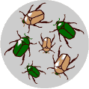

- There is differential reproduction.  Since the environment can't support unlimited population growth, not all individuals get to reproduce to their full potential. In this example, green beetles tend to get eaten by birds and survive to reproduce less often than brown beetles do. |  | 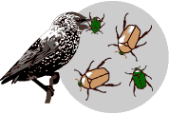

- There is heredity.  The surviving brown beetles have brown baby beetles because this trait has a genetic basis. |  | 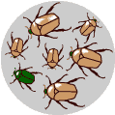

- End result:  The more advantageous trait, brown coloration, which allows the beetle to have more offspring, becomes more common in the population. If this process continues, eventually, all individuals in the population will be brown. |  | 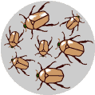
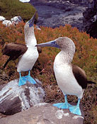
If you have variation, differential reproduction, and heredity, you will have evolution by natural selection as an outcome. It is as simple as that. Indeed, when we (humans) only allow organisms to produce young it is called animal husbandry or agriculture. There is no such wild animal as a Poodle. All dogs came from wolves that humans controlled.
Natural selection at work

Scientists have worked out many examples of natural selection, one of the basic mechanisms of evolution.
Any coffee table book about natural history will overwhelm you with full-page glossies depicting amazing adaptations produced by natural selection, such as the examples below.

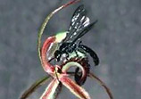
Behavior can also be shaped by natural selection. Behaviors such as birds' mating rituals, bees' wiggle dance, and humans' capacity to learn language also have genetic components and are subject to natural selection. The male blue-footed booby, shown to the right, exaggerates his foot movements to attract a mate.
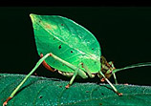
Orchids fool wasps into "mating" with them.

Katydids have camouflage to look like leaves.

Non-poisonous king snakes mimic poisonous coral snakes.

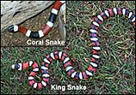
In some cases, we can directly observe natural selection. Very convincing data show that the shape of finches' beaks on the Galapagos Islands has tracked weather patterns: after droughts, the finch population has deeper, stronger beaks that let them eat tougher seeds.
In other cases, human activity has led to environmental changes that have caused populations to evolve through natural selection. A striking example is that of the population of dark moths in the 19th century in England, which rose and fell in parallel to industrial pollution. These changes can often be observed and documented.

Artificial selection
Long before Darwin and Wallace, farmers and breeders were using the idea of selection to cause major changes in the features of their plants and animals over the course of decades. Farmers and breeders allowed only the plants and animals with desirable characteristics to reproduce, causing the evolution of farm stock. This process is called artificial selection because people (instead of nature) select which organisms get to reproduce.
As shown below, farmers have cultivated numerous popular crops from the wild mustard, by artificially selecting for certain attributes.

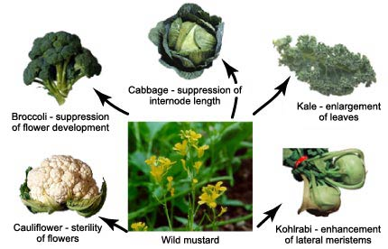
These common vegetables were cultivated from forms of wild mustard. This is evolution through artificial selection.

Misconceptions about natural selection
Because natural selection can produce amazing adaptations, it's tempting to think of it as an all-powerful force, urging organisms on, constantly pushing them in the direction of progress — but this is not what natural selection is like at all.
First, natural selection is not all-powerful; it does not produce perfection. If your genes are "good enough," you'll get some offspring into the next generation — you don't have to be perfect. This should be pretty clear just by looking at the populations around us: people may have genes for genetic diseases, plants may not have the genes to survive a drought, a predator may not be quite fast enough to catch her prey every time she is hungry. No population or organism is perfectly adapted.
Second, it's more accurate to think of natural selection as a process rather than as a guiding hand. Natural selection is the simple result of variation, differential reproduction, and heredity — it is mindless and mechanistic. It has no goals; it's not striving to produce "progress" or a balanced ecosystem.

This is why "need," "try," and "want" are not very accurate words when it comes to explaining evolution. The population or individual does not "want" or "try" to evolve, and natural selection cannot try to supply what an organism "needs." Natural selection just selects among whatever variations exist in the population. The result is evolution.
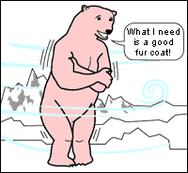
Evolution does not work this way.
At the opposite end scale, natural selection is sometimes interpreted as a random process. This is also a misconception. The genetic variation that occurs in a population because of mutation is random-but selection acts on that variation in a very non-random way: genetic variants that aid survival and reproduction are much more likely to become common than variants that don't. Natural selection is NOT random!
COEVOLUTION
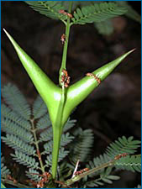
The term coevolution is used to describe cases where two (or more) species reciprocally affect each other's evolution. So for example, an evolutionary change in the morphology of a plant, might affect the morphology of an herbivore that eats the plant, which in turn might affect the evolution of the plant, which might affect the evolution of the herbivore...and so on.
Coevolution is likely to happen when different species have close ecological interactions with one another. These ecological relationships include:
- Predator/prey and parasite/host
- Competitive species
- Mutualistic species
Plants and insects represent a classic case of coevolution — one that is often, but not always, mutualistic. Many plants and their pollinators are so reliant on one another and their relationships are so exclusive that biologists have good reason to think that the "match" between the two is the result of a coevolutionary process.
But we can see exclusive "matches" between plants and insects even when pollination is not involved. Some Central American Acacia species have hollow thorns and pores at the bases of their leaves that secrete nectar (see image at right). These hollow thorns are the exclusive nest-site of some species of ant that drink the nectar. But the ants are not just taking advantage of the plant — they also defend their acacia plant against herbivores.
This system is probably the product of coevolution: the plants would not have evolved hollow thorns or nectar pores unless their evolution had been affected by the ants, and the ants would not have evolved herbivore defense behaviors unless their evolution had been affected by the plants.

A case study of coevolution: squirrels, birds, and the pinecones they love
The scene: The Rocky Mountains |  | Lodgepole Pines
The players: |  | 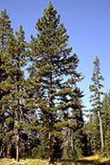
Red Squirrels | Crossbilled Birds
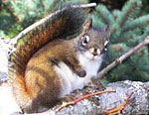 | 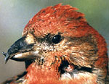
The plot:
In most of the Rocky Mountains, red squirrels are an important predator of lodgepole pine seeds. They harvest pinecones from the trees and store them through the winter. However, the pine trees are not defenseless: squirrels have a difficult time with wide pinecones that weigh a lot but have fewer seeds. Crossbill birds live in these places and also eat pine seeds, but the squirrels get to the seeds first, so those birds don't get as many seeds.
However, in a few isolated places, there are no red squirrels, and crossbills are the most important seed predator for lodgepoles. Again, the trees are not defenseless: crossbills have more difficulty getting seeds from cones with large, thick scales. But the birds have a mode of counterattack: crossbills with deeper, shorter, less curved bills are better able to extract seeds from tough cones.
The stage is set, but the question remains: has coevolution happened? In order to show coevolution, we need evidence that suggests that the prey (the trees) have evolved in response to the predator (squirrels or birds) and that the predator has evolved in response to the prey. Researchers Craig Benkman, William Holiman, and Julie Smith set out to see if their observations would support the hypothesis of coevolution.
Based on their hypotheses, the scientists who did this study made some predictions:
- There should be geographic differences in the pinecones.
If the trees have evolved in response to their seed predators, we should observe geographic differences in pinecones: where squirrels are the main seed predator, trees should have stronger defenses against squirrel predation, and where birds are the main seed predator, trees should have stronger defenses against bird predation. This turns out to be true. Where there are squirrels, the pinecones are heavier with fewer seeds, but have thinner scales, like the pinecone on the left. Where there are only crossbills, pinecones are lighter with more seeds, but have thick scales, like the one on the right.
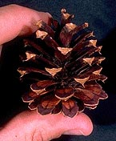 |  | 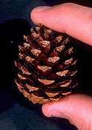
Lodgepole pine cones adapted to squirrels — easier for crossbills to eat. |  | Lodgepole pine cones adapted to crossbills — easier for squirrels to eat.
- Geographic differences in the predators should correspond with differences in the prey.
If the crossbills have evolved in response to the pine trees, we should observe geographic differences in birds: where the pinecones have thick scales, birds should have deeper, less curved bills (below left) than where the pinecones have thin scales (below right). This also turns out to be true.
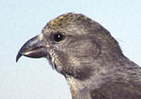 |  | 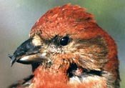
The bill is less curved on this female red crossbill |  | The bill is more deeply curved on this male red crossbill
- So we have evidence that the trees have adapted to the birds (and the squirrels) and that the birds have adapted to the trees. (However, note that we don't have evidence that the squirrels have adapted to the trees.) It's easy to see why this is called a coevolutionary arms race: it seems possible for the evolutionary "one-upping" to go on and on...even thicker-scaled pinecones are favored by natural selection, which causes deeper-billed birds to be favored, which causes even thicker-scaled pinecones to be favored, and so on...
I hope this helped you see that the natural world is a complex integration of living organisms as well as many biogeochemical cycles. Humans tend to disrupt these biological communities - the BIOMES.
Biome: A biome is a major geographical area of ecologically similar communities of plants, animals, and soil organisms, often referred to as ecosystems. Biomes are defined based on factors such as plant structures (such as trees, shrubs, and grasses), leaf types (such as broadleaf and needleleaf), plant spacing (forest, woodland, savanna), and other factors like climate. Biomes are not defined by genetic, taxonomic, or historical similarities. Biomes are often identified with particular patterns of ecological succession and climax vegetation.

Biomes are often given local names. For example, a Temperate grassland or shrubland biome is known commonly as steppe in central Asia, savanna or veldt in southern Africa, prairie in North America, pampa in South America and outback or scrub in Australia.

Let’s talk about tropical forests: Tropical and seasonal.
Let’s talk about deserts: Hot and cold.
Let’s talk about temperate forests: Deciduous and coniferous.
Let’s talk about boreal forests: Mountains and taiga.
Let’s talk about tundra: Water and temperature. Arctic and Alpine.

Marine ecosystems: Concept of vertical stratification, photic zone. Benthic vs pelagic. Abyssal vs littoral. Fig 5.14
Tidal shores, estuaries, salt marshes, tidal pools.

Freshwater ecosystems: Lakes and thermocline. Local conditions. Wetlands and politics (50-99% lost)-swamp, bog, fens. Streams.

Biodiversity, invasive species. Pollution. Passenger pigeon, bison, wild turkey, commercialism.

Finish up next class with Endangered Species.

