Ecological Impact I = PAT

Carrying capacity: The population of an organism within an ecosystem is in equilibrium. This is due to a complex set of relationships collectively known as the ecosystem's carrying capacity. Generally it is the supportable population of an organism, given the food, habitat, water and other necessities available within an ecosystem. For the human population more complex variables such as sanitation and medical care are sometimes considered as part of the necessary infrastructure.

Iowa 2006 = 2,982,085 Bangladesh 2007 = 150,448,339

In 1798 Thomas Malthus published An Essay on the Principle of Population, describing his theory of quantitative development of human populations:
“I think I may fairly make two postulata. First, That food is necessary to the existence of man. Secondly, That the passion between the sexes is necessary and will remain nearly in its present state. These two laws, ever since we have had any knowledge of mankind, appear to have been fixed laws of our nature, and, as we have not hitherto seen any alteration in them, we have no right to conclude that they will ever cease to be what they now are, without an immediate act of power in that Being who first arranged the system of the universe, and for the advantage of his creatures, still executes, according to fixed laws, all its various operations.
...
Assuming then my postulata as granted, I say, that the power of population is indefinitely greater than the power in the earth to produce subsistence for man. Population, when unchecked, increases in a geometrical ratio.”
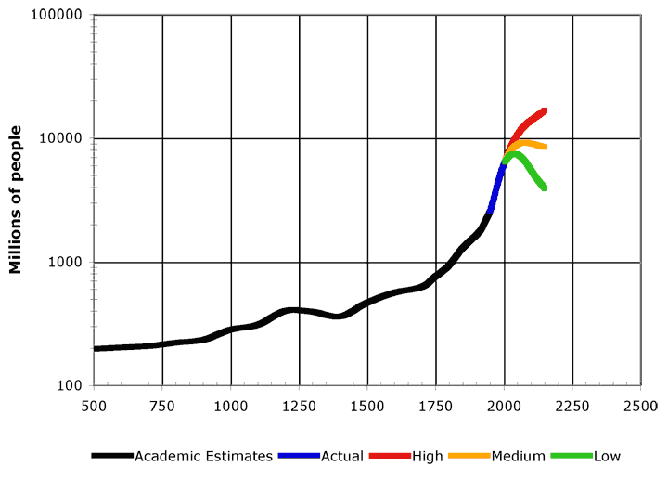
– Malthus 1798
How would you suggest dealing with pronatalist pressures?

(Economic, security, pride, etc.)

Wait/hope for demographic transitions?
………………………………..

What do you think about religions that emphasize unregulated birthrates?

How does this strategy compare to Malthus’ prediction?

Is forced contraception justifiable in any circumstance?

Is any contraception strategy justifiable for individuals with or without incentives?

