Equivocation is the use in a syllogism (a logical chain of reasoning) of a term several times, but giving the term a different meaning each time.
A feather is light.
What is light cannot be dark.
Therefore, a feather cannot be dark.
In this use of equivocation, the word "light" is first used as the opposite of "heavy", but then used as a synonym of "bright" (the fallacy usually becomes obvious as soon as one tries to translate this argument into another language). Because the "middle term" of this syllogism is NOT one term, but two separate ones masquerading as one (all feathers are indeed "not heavy", but is NOT true that all feathers are "not bright"), equivocation is actually a kind of the fallacy of four terms.
The fallacy of equivocation is often used with words that have a strong emotional content and many meanings. These meanings often coincide within proper context, but the fallacious arguer does a semantic shift, slowly changing the context as they go in such a way to achieve equivocation by treating distinct meanings of the word as equivalent.
In English language, one equivocation is with the word "man", which can mean both "member of species Homo sapiens" and "male member of species Homo sapiens". A well-known equivocation is
"Do women need to worry about man-eating sharks?" where "man-eating" is taken as "devouring only male human beings".
A separate case of equivocation is metaphor:
A Jackass is a male member of the species Equus asinus
All Jackasses have long ears
Karl is a jackass
Therefore, Karl has long ears
Here the equivocation is the metaphorical use of "jackass" to imply a stupid or obnoxious person instead of a male ass.
Margarine is better than nothing
Nothing is better than butter
Therefore margarine is better than butter
This equivocation exploits two different meanings of the word "nothing" to come to an apparent conclusion about the relative merits of two different things without actually making reference to any of their respective merits. In the first statement, "nothing" really means "dry bread" (such that the sentence means "it is preferable to have margarine [on bread] than nothing at all"), whereas in the second, it means, literally, "no thing" (so the sentence means "there exists no thing that is better than butter").

What is a conceptual framework?
There are many ways to explain a conceptual framework. It can be any or all of the following:
- A set of coherent ideas or concepts organized in a manner that makes them
easy to communicate to others.
- An organized way of thinking about how and why a project takes place,
and about how we understand its activities.
- The basis for thinking about what we do and about what it means, influenced
by the ideas and research of others.
- An overview of ideas and practices that shape the way work is done
in a project.
- A set of assumptions, values, and definitions under which we all work together.

Why do we need a framework when doing research?
A framework can help us to explain why we are doing a project in a particular way. It can also help us to understand and use the ideas of others who have done similar things.
We can use a framework like a travel map. We can read a map, because others before us have come up with common symbols to mark streets, lakes, highways, cities, mountains, rivers, etc...The scale on a map tells us how far apart different places are, so we will get an idea how long it might take us to get from one point to the next. A map also shows us that there may be many different paths that can be taken to get to the same place.
A framework can help us decide and explain the route we are taking: why would we use certain methods and not others to get to a certain point. People might have tried a similar path before and have had different experiences using one road versus another. Or, there may be paths that have never been explored. With a conceptual framework, we can explain why we would try this or that path, based on the experiences of others, and on what we ourselves would like to explore or discover.
…………………………………………………………………………………………..

http://www.clearwater.org/pcbs/slideshow/slide1.html http://www.cleanupge.org/pcbs.html
Hudson River PCBs are a serious health risk.
- Polychlorinated biphenyls (PCBs) can damage the immune, reproductive, nervous and endocrine systems. They can impair children's physical and intellectual development.
- PCBs cause cancer in animals and are strongly linked to human cancer, according to studies by leading health agencies - the International Agency for Research on Cancer; National Toxicology Program; EPA; World Health Organization; etc.
- GE says PCBs do not hurt people, citing a study it commissioned on workers at its Hudson Falls plant. The NYS Department of Health and many independent scientists critiqued the research and said it does not support GE's claims.
- According to the EPA, cancer risks from eating upper river PCB-contaminated fish are 1,000 times its goal for protection and 10 times the highest level generally allowed by Superfund Law.
Hudson River PCBs won't go away naturally.
- PCBs were designed not to break down. They are "persistent organic pollutants" that remain in the environment indefinitely.
- GE claims river microbes eliminate PCBs naturally, but the EPA found less than 10 percent have broken down. After breakdown, PCBs remain toxic and are more readily spread throughout the ecosystem.
- GE claims Hudson River PCB pollution has dropped 90 percent, a deceptive statistic because the drop occurred when discharges were banned in the late '70s. Since the mid-'80s, levels have remained quite constant and well above acceptable limits. The EPA's independent, peer-reviewed science predicts the problem will last into the foreseeable future without remediation.
- GE's PCBs are responsible for "Eat None" health advisories for women of childbearing age and children for all fish from all Hudson River locations.

http://www.rachelcarson.org/ http://sociology.ucsc.edu/whorulesamerica/power/wealth.html
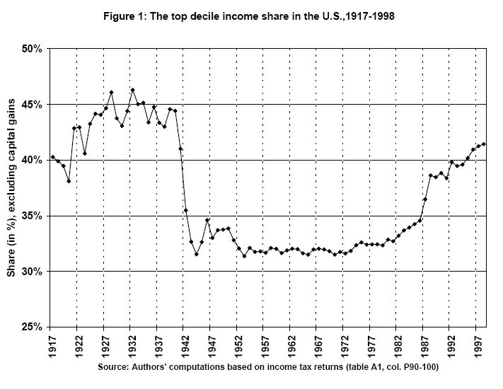
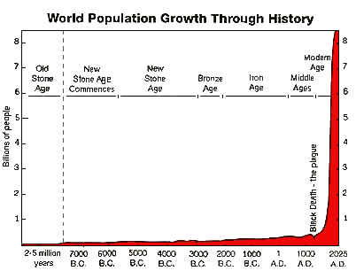

http://en.wikipedia.org/wiki/Sustainable_development ,

http://www.colby.edu/biology/BI17x/expt_method.html

