Overpopulation in China has been much documented within the past 50 years. Books have been written on the Chinese birth control and One Child policy, and critics have highlighted the new problems that these policies have created. Our project summarizes the scientific research and analysis up until this point and emphasizes the disparity between policy and adequate scientific data and measures available to the policy makers.
Although population growth of China has been curtailed by the measures taken by the government, the population of 1,294,681,023 people is still much larger than anyone imagined possible...

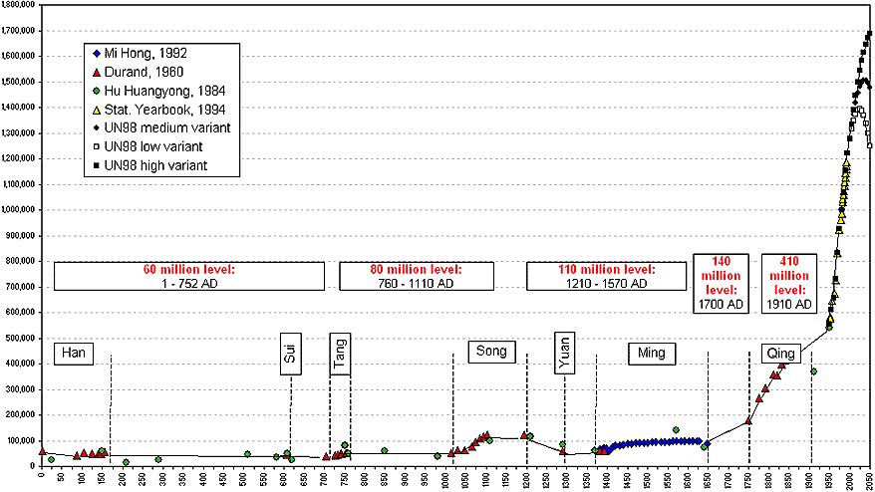
China’s Population Growth, A.D. 0–2050

(China Population Information and Research Center) Population Growth, Crude Birth and Death Rates,
