What is "Hard Water"?
Perhaps you have on occasion noticed mineral deposits on your cooking dishes, or rings of insoluble soap scum in your bathtub. These are not signs of poor housekeeping, but are rather signs of hard water from the municipal water supply. Hard water is water that contains cations with a charge of +2, especially Ca²⁺ and Mg²⁺. These ions do not pose any health threat, but they can engage in reactions that leave insoluble mineral deposits. These deposits can make hard water unsuitable for many uses, and so a variety of means have been developed to "soften" hard water; i.e.,remove the calcium and magnesium ions.

Problems with Hard Water
Mineral deposits are formed by ionic reactions resulting in the formation of an insoluble precipitate. For example, when hard water is heated, Ca²⁺ ions react with bicarbonate (HCO₃⁻) ions to form insoluble calcium carbonate (CaCO₃), as shown in Equation 1.
This precipitate, known as scale, coats the vessels in which the water is heated, producing the mineral deposits on your cooking dishes. In small quantities, these deposits are not harmful, but they may be frustrating to try to clean. As these deposits build up, however, they reduce the efficiency of heat transfer, so food may not cook as evenly or quickly in pans with large scale deposits. More serious is the situation in which industrial-sized water boilers become coated with scale: the cost in heat-transfer efficiency can have a dramatic effect on your power bill! Furthermore, scale can accumulate on the inside of appliances, such as dishwashers, and pipes. As scale builds up, water flow is impeded, and hence appliance parts and pipes must be replaced more often than if Ca²⁺ and Mg²⁺ ions were not present in the water.

Some Strategies to "Soften" Hard Water
For large-scale municipal operations, a process known as the "lime-soda process" is used to remove Ca²⁺ and Mg²⁺ from the water supply. Ion-exchange reactions, similar to those you performed in this experiment, which result in the formation of an insoluble precipitate, are the basis of this process. The water is treated with a combination of slaked lime, Ca(OH)₂, and soda ash, Na₂CO₃. Calcium precipitates as CaCO₃, and magnesium precipitates as Mg(OH)₂. These solids can be collected, thus removing the scale-forming cations from the water supply.
To see this process in more detail, let us consider the reaction for the precipitation of Mg(OH)₂. Consultation of the solubility guidelines in the experiment reveals that the Ca(OH)₂ of slaked lime is moderately soluble in water. Hence, it can dissociate in water to give one Ca²⁺ ion and two OH⁻ ions for each unit of Ca(OH)₂ that dissolves. The OH⁻ ions react with Mg²⁺ ions in the water to form the insoluble precipitate. The Ca²⁺ ions are unaffected by this reaction, and so we do not include them in the net ionic reaction (Equation 2). They are removed by the separate reaction with CO₃²⁻ ions from the soda ash.
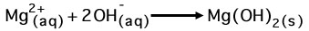
Household water softeners typically use a different process, known as ion exchange. Ion-exchange devices consist of a bed of plastic (polymer) beads covalently bound to anion groups, such as -COO⁻. The negative charge of these anions is balanced by Na⁺ cations attached to them. When water containing Ca²⁺ and Mg²⁺ is passed through the ion exchanger, the Ca²⁺ and Mg²⁺ ions are more attracted to the anion groups than the Na⁺ ions. Hence, they replace the Na⁺ ions on the beads, and so the Na⁺ ions (which do not form scale) go into the water in their place.

Figure 1
When hard tap water passes through the ion exchanger (left), the calcium ions from the tap water replace the sodium ions in the ion exchanger. The softened water, containing sodium ions in place of calcium ions, can be collected for household use.
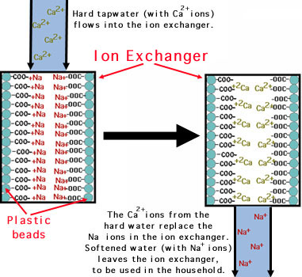
Unfortunately, many people with high blood pressure or other health problems must restrict their intake of sodium. Because water softened by this type of ion exchange contains many sodium ions, people with limited sodium intakes should avoid drinking water that has been softened this way. Several new techniques for softening water without introducing sodium ions are beginning to appear on the market.

Practice questions on Water Hardness
1. How could you use a flame test to distinguish between hard and soft water? (HINT: For which ions in hard and soft water have you performed experimental flame-test observations in Experiment 2?)
2. After a period of time, your ion-exchange water softener (the kind described above) no longer removes hard-water ions. How can you "refresh" your water softener, using a material obtained from the grocery store?
3. The deionized water in the Chemistry Department is produced by ion exchange that uses H⁺ ions, rather than Na⁺ ions,to replace the cations found in the water.Explain why the pH of deionized water is typically found to be around 6.
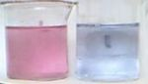
…………………………………………………………………………………………. …………………………………. Eriochrome Black T is a complexometric indicator that is part of the complexometric titrations, eg. in the water hardness determination process. It is an azo dye.
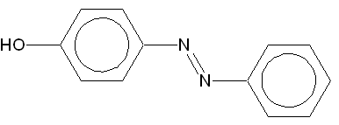
In its protonated form, Eriochrome Black T is blue and it turns red when it forms complex with calcium, magnesium, or other metal ions. Its chemical formula can be written as HOC₁₀H₆N=NC₁₀H₄(OH)(NO₂)SO₃Na.
Eriochrome Black T is blue, but turns red in the presence of metals.
Applications: When used as an indicator in an EDTA titration the characteristic blue end-point is reached when sufficient EDTA is added and metal ions form complexes with the EDTA instead of the eriochrome. Eriochrome Black T has other applications as well. It can be used to measure the hardness (i.e. the concentration of calcium and magnesium ions) in water. It is also used to detect the presence of rare earth metals.
-----------------------------------------------------------------------------------------------------------------------------------------------
Materials Section math example:
10000 mg / 1000 ml (L) = 10 mg/ml , you add 2.5 ml (Ex Proc #4) = 25 mg /500ml .. so = same as 50 mg / L

Remember to test pH! This insures standardized ionization.

Now, test hardness the same as last week by adding the hardness buffer, Black T, and titrating with EDTA. Same formula applies. Lab report includes all calculations and a well organized and labeled graph. Thank YOU!

